**How to install git on Windows**

* Usage of git?

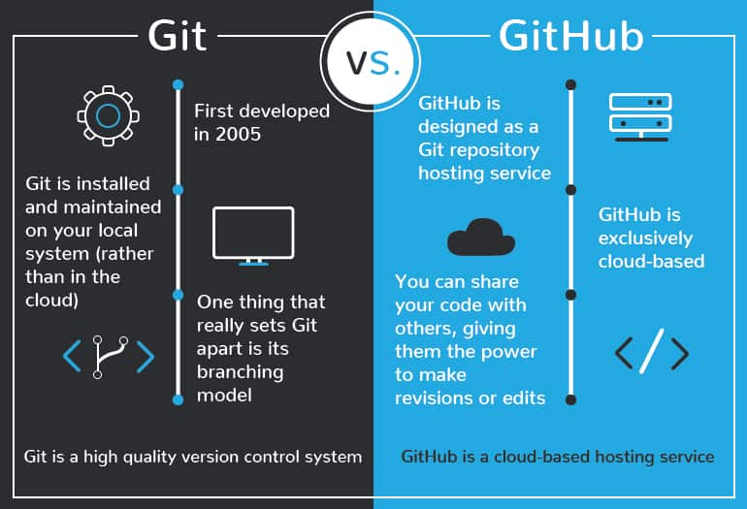

**Step 1: Create a github account**

1. Access the link <https://github.com/>
2. Sign up using your gmail account



1. Enter your mail and click on continue and create a password and click on continue and then give a user name and click on continue, then give yes or no, if you want to receive any product updates and click on continue

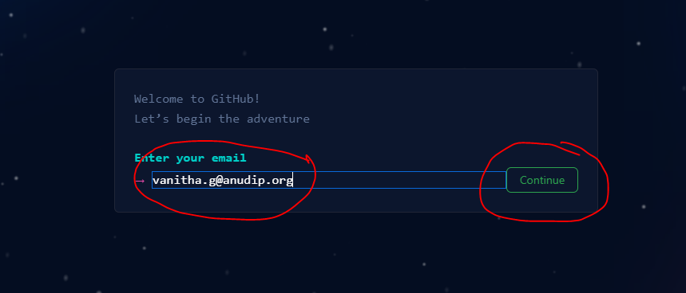

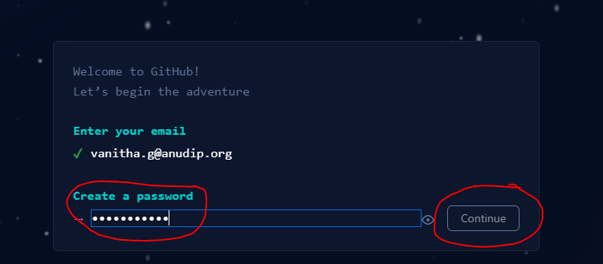

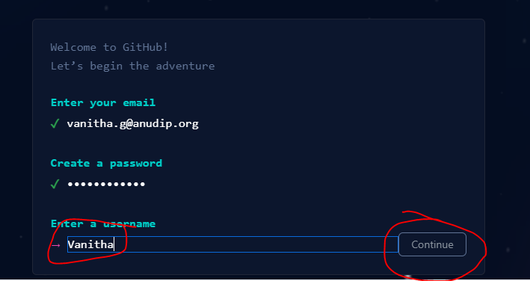

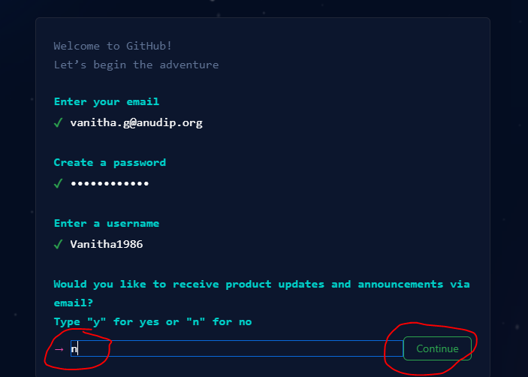

1. Solve the Puzzle to authenticate yourself, click on Start puzzle, once verification is done, click on create account

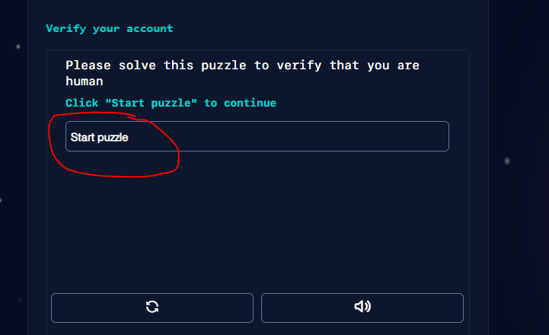

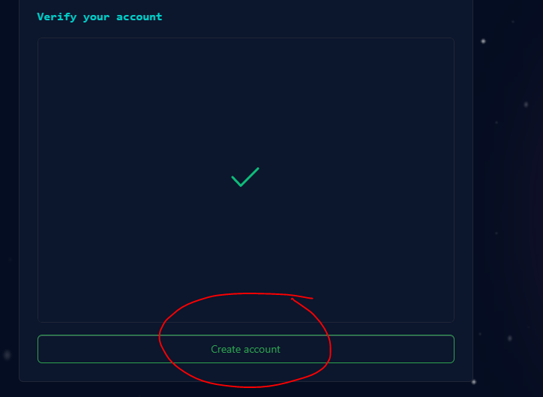

1. Enter the code you have received in your mailing account

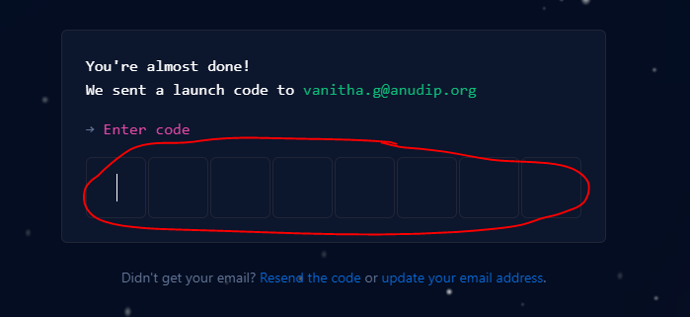

1. Select a student option for yourself, click on continue and select what for it you are using





1. Continue for free



1. Account is created, your dashboard should look like this

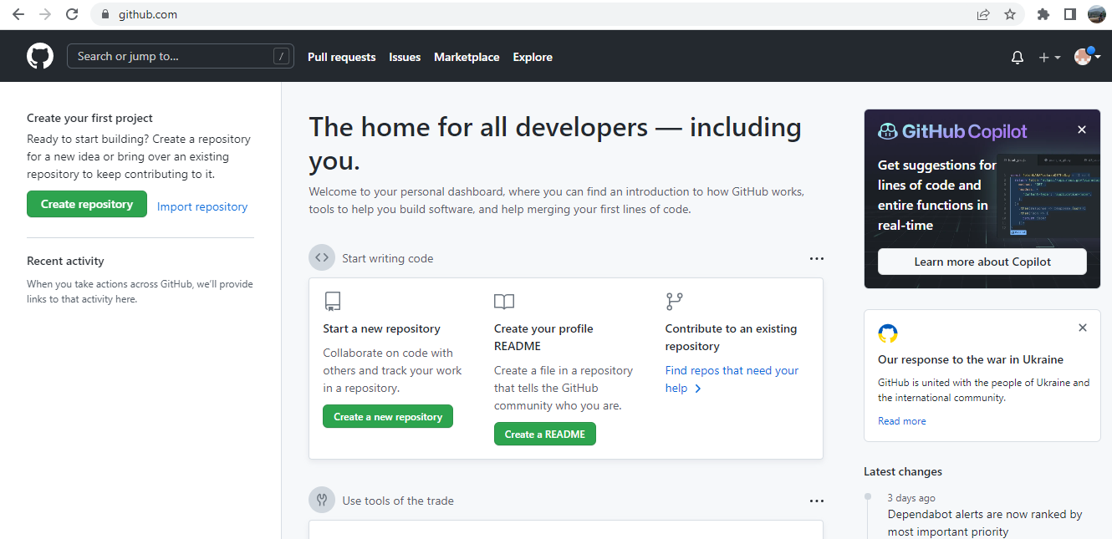

Step 2: Creating a repository

1. Click on the + icon and select New repository, give a repository name, let it be public and select the option of add a Readme file and click on create repository option.

